SmartCare v0.5 - Architecture and Refactoring Workbook
Week 8 student resource

Current Architecture Problems
Problem | Evidence | Impact | Refactoring
No separation between workflow and domain | Booking logic was written directly into scripts | Domain rules get mixed with coordination | Move workflow into AppointmentService
No persistence boundary | Appointments stored in plain variables | Cannot swap storage without rewriting logic | Introduce AppointmentRepository interface
frozen=True on Appointment blocked mutation | cancel() failed at runtime | Status could not be changed | Remove frozen=True from Appointment only
Import paths assumed package structure with no __init__.py | ModuleNotFoundError on run | Code could not execute | Consolidate into one file until packages are confirmed
Overlap check was misplaced | Draft placed it in the service | Domain rule lived outside the domain | Move overlaps() onto Appointment
Provisional features included in core | NotificationManager suggested by AI | Unnecessary coupling and complexity | Reject until confirmed requirement exists

Layer Responsibilities
Layer | Responsibilities | Must not contain
Presentation | Accept input, display output, call service | Business rules, SQL, domain logic
Service | Coordinate use cases, enforce workflow order | SQL, UI logic, domain state rules
Domain | Own state, validate invariants, enforce transitions | SQL, UI, service coordination
Repository | Define data-access contract as an interface | SQL implementation, business rules
Persistence | Implement the repository contract | Business rules, UI, service logic

Architecture Diagram
Insert SmartCare v0.5 architecture and dependency direction.
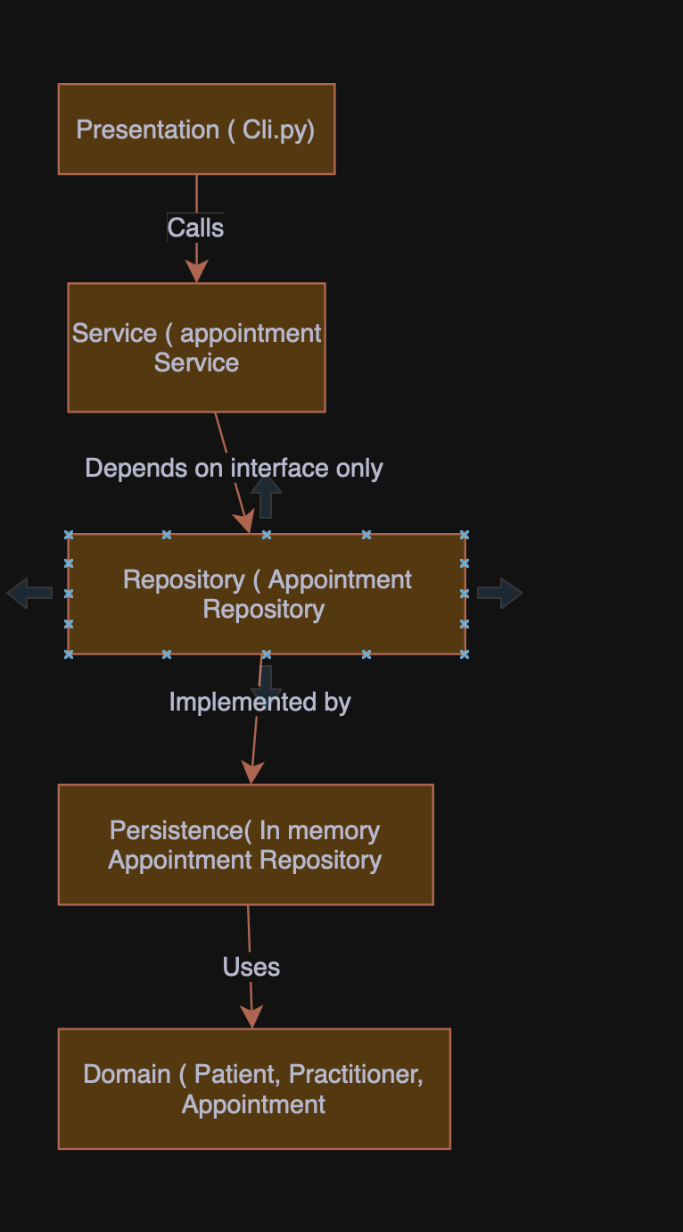

SOLID Review
Principle | Relevant? | Evidence | Decision
SRP | Yes | Appointment owns only state and transitions; AppointmentService owns workflow only. | Applied
OCP | Partly | AppointmentRepository allows new persistence implementations without changing the service. | Applied at repository boundary
LSP | Partly | InMemoryAppointmentRepository must honour the full AppointmentRepository contract. | Applied; relevant if a second implementation is added
ISP | Yes | Repository defines only three operations needed by current use cases. | Applied; no unused methods forced on implementors
DIP | Yes | AppointmentService depends on the abstract AppointmentRepository, not the concrete class. | Applied

AI Architecture Review
AI suggestion | Observed problem? | Decision | Reason | Verification
Add AppointmentRepository interface | Yes — no persistence boundary existed | Accepted | Allows storage to change without touching the service | Service tested with in-memory implementation
Move overlaps() to Appointment | Yes — overlap logic used appointment-level data | Accepted | Keeps domain behaviour inside the domain | Overlap check passes in verification run
Add SQLAlchemy | No confirmed persistence requirement | Rejected | Introduces a framework dependency not justified by current scope | No external dependencies needed to pass all checks
Add event bus for notifications | Notifications are provisional | Rejected | Adds coupling with no confirmed requirement | Not present in final code
Shared base class for Patient and Practitioner | No shared behaviour exists | Rejected | Inheritance without shared behaviour adds complexity | Both classes remain independent

